**CMIS 242 6382 Intermediate Programming – Project 2**

Student Name: Xingyi Zhang

Instructor: Vladimir Gubanov

Date: June 15, 2020

**Test Cases and Result Displays**

1. **Enter a Hybrid automobile with MPG greater than 40:**

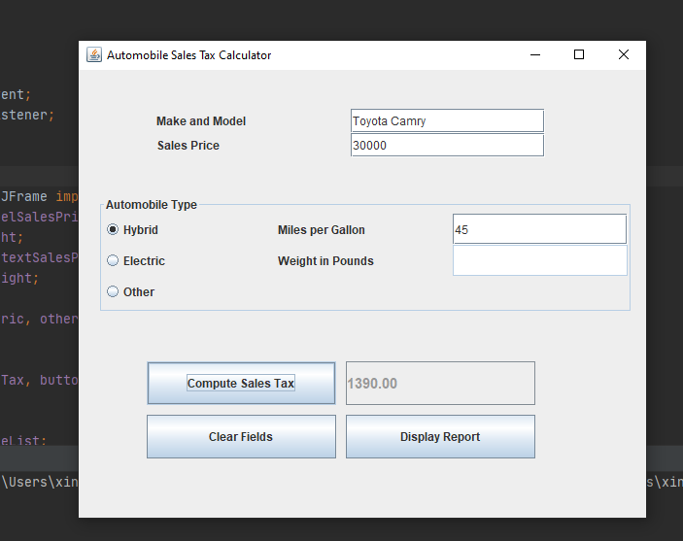

Analysis:

The expected calculation is: 30000 * 0.05 – 100 – (45 – 40) * 2 = 1390.

The result matches with the expected output. This test case is passed.

1. **Enter an Electric automobile with the weight greater than 3000 pounds:**

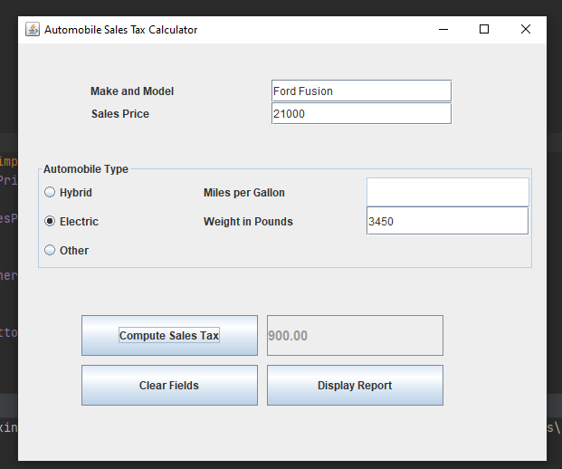

Analysis:

The expected result = 21000 * 0.05 – 150 = 900.

The output matches with the expected result.

The program has passed this testcase.

1. **Enter an “Other” automobile with the sale price of $14530:**

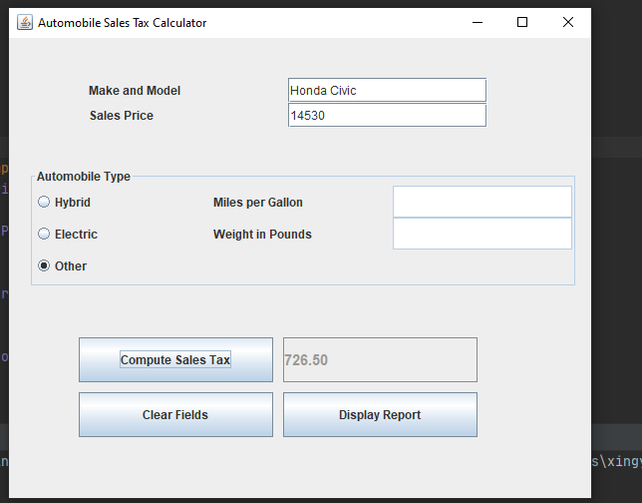

Analysis:

The expected output = 14530 * 0.05 = 726.50.

The result matches the expected output.

The program has passed this test case.

1. **Enter a hybrid automobile with MPG of 36:**

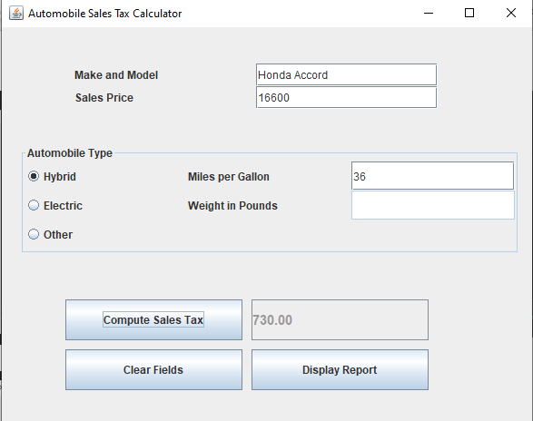

Analysis:

Expected result is 16600 * 0.05 - 100 = 730.

The output matches with the expected result.

The program has passed this testcase.

1. **Click the “Clear Form” button, showing the default form with “other” selected**

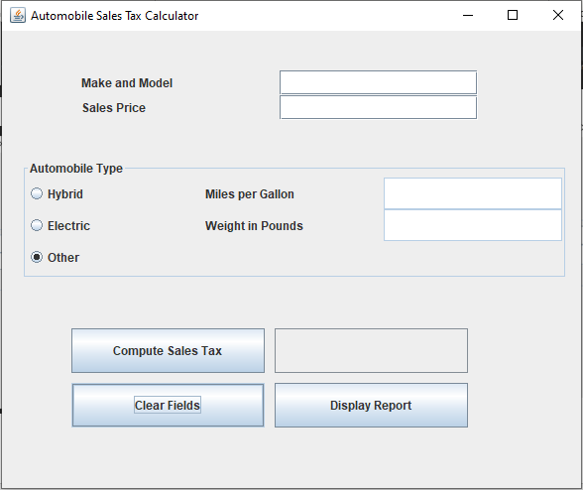

Analysis:

Expected display: “other” is selected by default and make the middle section text fields non-editable.

The output matches with the expected result.

The program has passed this testcase.

1. **Enter an electric with less than 3000 pounds in weight:**

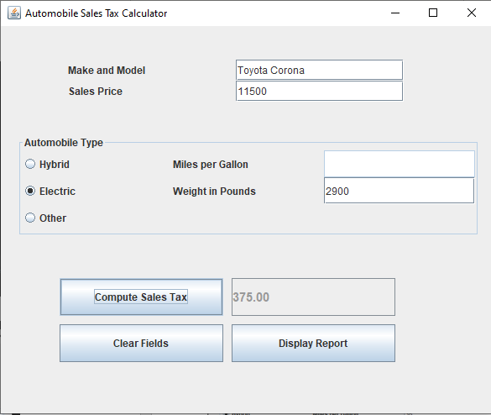

Analysis:

Expected result = 11500 * 0.05 – 200 = 375.

The output matches with the expected result.

The program has passed this testcase.

1. **Enter a hybrid automobile with MPG 0f 37:**

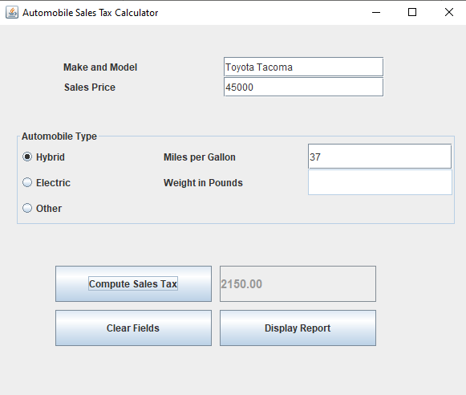

Analysis:

Expected output: 45000 * 0.05 – 100 = 2150

The output matches with the expected result.

The program has passed this testcase.

1. **After clicking the “Display Report” Button:**

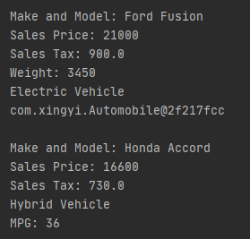 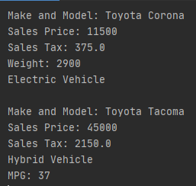

Analysis:

Expected output: Displaying all information properly labeled.

The output matches with the expected result.

The program has passed this testcase.